Problems 1

Rules for Quizzes and Examinations:
1. No cell phones.
2. No communication between students.
3. A student can use only his/her calculator.
4. No passing of anything among students, including a dictionary, calculator, pen, pencil, ruler, eraser, the periodic table, etc.
5. A student can take only:
a pen,
a pencil,
a ruler,
an eraser,
spare pens and pencils,
a calculator (not a cell phone),
6. A student cannot take:
any paper,
dictionary.
cell phone (even as a calculator).
7. Pay attention: you must learn by heart all terms and constants used in the problems of this Module. You cannot have any background materials, tables with constants etc.

Requirements for problems:
- Solve in quantities and only then find the final number.
- Solution must contain:
  - Extreme case analysis,
  - Dimensions and units checking
- Don’t forget to transfer all the units into the SI units:
- hours, minutes into seconds,
- miles, kilometers into meters,
- velocities into m/s,
- Celsius degrees into kelvins etc.

The facts you must remember to solve the problems successfully:
g = 9.8 m/s² - the gravitational acceleration
1mi = 1609 m - one mile
1min = 60 s - one minute
1h = 60 min - one hour
ρ_{w} = 1000 kg/m³ - the density of water

Some formulas:

F=-kx F – spring force
k – spring constant
x – displacement from the equilibrium position

P=ρgh P - pressure in a liquid
g – gravitational acceleration
h – distance from the surface of the liquid

F=PA F – force on a flat surface
P – pressure on a surface
A – area of a surface

V=(2gh)^{0.5} V – speed of a liquid leaking from a vessel
g – gravitational acceleration
h – distance from the surface of the liquid
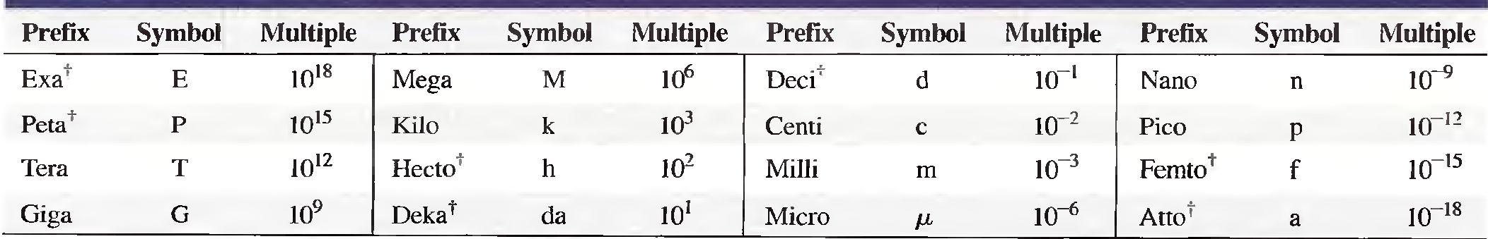

Thus:
    - 1m=10 dm (decimeters)
    - 1 s = 1000 ms, etc.
Kinematics

1
An object starts from 30 m/s velocity and reaches 126 km/h in a 1 km distance. Assuming a constant acceleration, what was the elapsed time?
{Answer: 30.769 s}

2
The distance an ant moves in a straight-line motion is given by
x = 0.01t³ - 0.05t² + 1.5t centimeters, where t is in seconds.
(a)Calculate the velocity for t = 5 s.
(b)What is the average velocity for the time interval from 1 to 2 min?
(c)Calculate the acceleration for t = 2 min.
(d)What is the average acceleration for the time interval from 1 to 2 min?
(e)Is the formula realistic for long times?
{Answer: a) 1.75 cm/s; b) 2.445 m/s; c) 7.100 cm/s²; d) 5.300 cm/s²; e) no}

3
The position of a particle is given in a certain coordinate system by the vector r(t) = (4 m) cos(πt/T)i - (4m) sin(πt/T)j]. Find the displacement vector at times (a) t = T/3, (b) t = T/2, and (c) t = 2T. In each case, compute the distance to the origin. (d) What is the angle that the position vector makes with the + x-axis for arbitrary t? (The angles are in radians).
{Answer: a) T/3: (2.00 m)i - (3.4641 m)j; b) T/2: (-4.00 m)j; c) 2T: (4.00 m)i; the distance to the origin is 4.00 m for each case; d) −πt/T}

Motion graphs

4
See the graph below. Calculate the instantaneous velocity at:
- t= 0.5 s
- t = 2 s
- t = 4 s
- t = 5 s
- Is it possible to calculate for t=1 s, 3 s, 4.5 s?
Calculate the average velocity for time intervals:
- from 0 to 1 seconds
- from 0 to 2 seconds
- from 2 to 4 seconds
- from 1 to 6 seconds
{Answer: a) 0; b) 20 m/s; c) 0; d) -26.67 m/s; e) no; f) 0; g) 10 m/s: h) 10 m/s; i) 0 m/s}

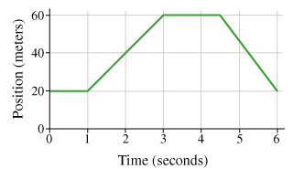

5
See the graph below. Initial conditions: at t=0 S₀=0. Calculate the position of the object at
- t = 1 s
- t = 2 s
- t = 6 s
Calculate the displacement of an object over a time interval:
- from 0 to 4 seconds
- from 2 to 6 seconds
- from 4 to 8 seconds
Calculate the average velocity for a time interval:
- from 0 to 4 seconds
- from 4 to 10 seconds
Calculate the instantaneous acceleration at:
- t = 0.5 s
- t = 3 s
- t = 8 s
- Is it possible to calculate for t=1 s, 2 s, 4 s, 7 s?
{Answer: a) 0.5 m; b) 1.5 m; c) 11.5 m; d) 5.5 m; e) 10.0 m; f) 11.25 m; g) 1.375 m/s; h) 2 m/s; i) 1 m/s²; j) 1 m/s²; k) -1.5 m/s²; l) no}

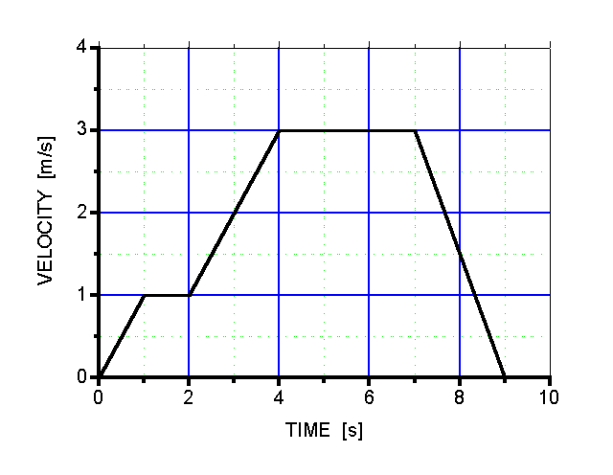

6
See the graph below. Initial conditions: at t=0 S₀=0, V₀=0.
Calculate the instantaneous velocity at:
- t = 1 s
- t = 2 s
- t = 3 s
- t = 5 s
Calculate the position of the object at:
- t = 1 s
- t = 2 s
- t = 3 s
Calculate the displacement of an object over a time interval:
- from 1 to 2 seconds
- from 5 to 7 seconds
Calculate the average velocity for time interval:
- from 0 to 1 seconds
- from 2 to 7 seconds
Calculate the average acceleration for time interval:
- from 1 to 3 seconds
- from 0.5 to 5.5 seconds
- from 0 to 6 seconds
- from 0 to 7 seconds

{Answer: a) -1 cm/s; b) -1.5 cm/s; c) -0.5 cm/s; d) 1.5 cm/s; e) -1/3 cm; f) -11/6 cm (-1.83333 cm);
g) -17/6 cm (-2.83333 cm); h) -1.5 cm; i) 23/6 cm (3.83333 cm); j) -1/3 cm/s; k) 23/30 cm/s (0.766667 cm/s)
l) 0.25 cm/s²; m) 0.425 cm/s²; n) 1/3 cm/s²; o) 2/7 cm/s²}

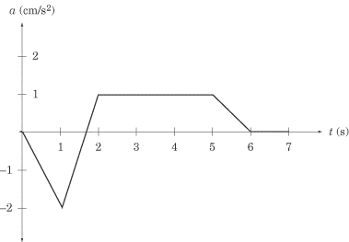

Dynamics

7
A forensic expert wants to examine the striations on a bullet fired by a gun. A bullet of mass 2.0 g is fired from the gun with muzzle speed 1000 mi/h into a special resistive material. The bullet is stopped in a distance of 1.4 dm. If we assume the negative acceleration is constant, what is the acceleration of the bullet inside the material and what force is exerted on the bullet as it accelerates?
{Answer: 713.426 km/s2; 1.42685 kN}

8
Two blocks of masses M and m are connected by a light rope that passes over a frictionless pulley (see the picture below). Mass M sits on an inclined plane with an angle of inclination of Θ = 30°. The coefficient of static friction between mass M and the inclined plane is 0.20, while m = 3.0 kg. Determine the largest and smallest possible values of M for which the system remains in equilibrium. Calculate the force of static friction on the block of mass M = 6.0 kg.
{Answer: 9.180069 kg, 4.456294 kg, zero}

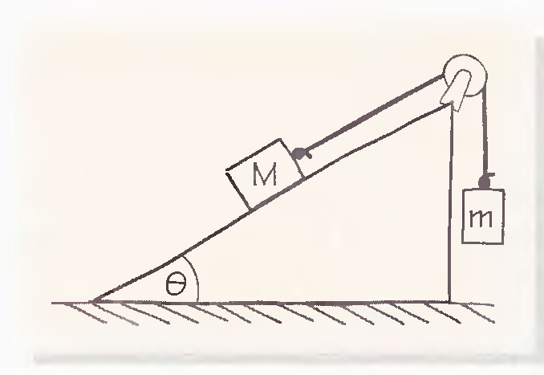

Springs

9
A spring gun is made by compressing a spring (assumed to be perfect) and latching it. A spring of constant k = 60 N/m is used and the latch is located at a distance of 7 cm from equilibrium. The pellets have mass 4 g. What is the muzzle velocity of the gun?
{Answer: 8.57321 m/s}

10
A nonstandard spring exerts a force F = -k₁x – k₂x³ to restore itself to equilibrium, where x is the distance from equilibrium. The values of k₁ and k₂ are 5.0 N/m and 15 N/m³ , respectively. Calculate the work done to stretch the spring from 0.10 to 0.20 m.
{Answer: 80.625 mJ}

11
Two masses are connected by a light string over a light, frictionless pulley. The table surface is also frictionless.
(a) Apply the work-energy theorem (it means the Dynamics: forces and acclelerations must not be used, solve only through work and energies) for this system to calculate the speed of the masses after the masses have moved a distance x starting from rest. Note that the work of the tensions drops out.
(b) Use this result to obtain the acceleration of the system.
{Answer: a) (2m₁gx/(m₁+m₂))^{0.5}; b) m₁g/(m₁+m₂)}

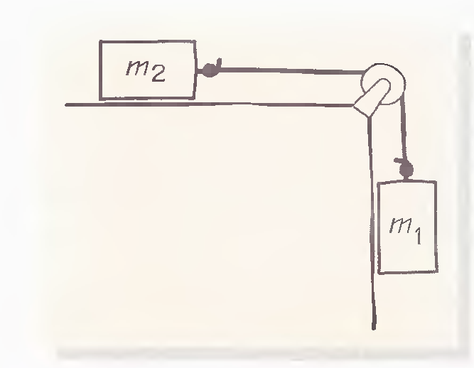

12
A fire rescue unit uses a tightly woven net to catch an 80-kg person who jumps out of a burning building from a height of 11 m.
(a) What is the impulse transmitted to the net? Find the numerical value and direction.
(b) If the net sinks 70 cm as it slows down the jumper, what is the average force exerted on the jumper by the net? Find the numerical value and direction.
{Answer: a) 1174.67 kg·m/s, down; b) 12.3200 kN, up}

13
A test car of mass 700 kg is moving at a speed of 15 mi/h when it crashes into a wall to test its bumper. If the car comes to rest in 0.3 s, how much average power is expended in the process?
{Answer: 52.4368 kW}

Dynamics at Circular Motion

14
Consider the conical pendulum, a mass on the end of a massless string, with the other end of the string fixed on a ceiling. Given the proper push, this pendulum can swing in a circle at a given angle Θ, maintaining the same height h throughout its swing.
(a) What is the free-body diagram for such a pendulum?
(b) If the mass of the pendulum is 0.2 kg, the length of the pendulum is 50 cm, and the angle at which it swings is Θ = 10⁰, what is the speed of the mass as it swings?
{Answer: 38.734 cm/s}

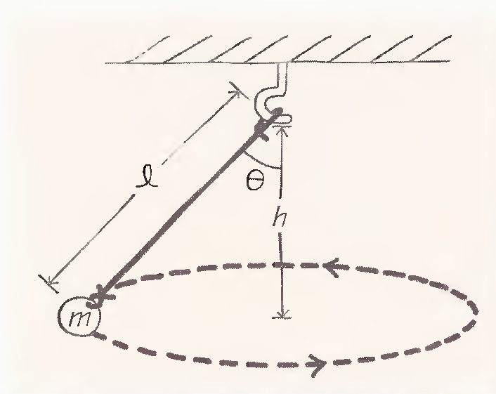

15
A small block slides in a horizontal circle on the inside of a conical surface, with the cone making an angle of 44⁰ with the vertical. Assuming that there is no friction between the block and the surface and the block slides with an angular speed of 3.8 rad/s, at what vertical height above the apex of the cone does the block slide?
{Answer: 72.775 cm}

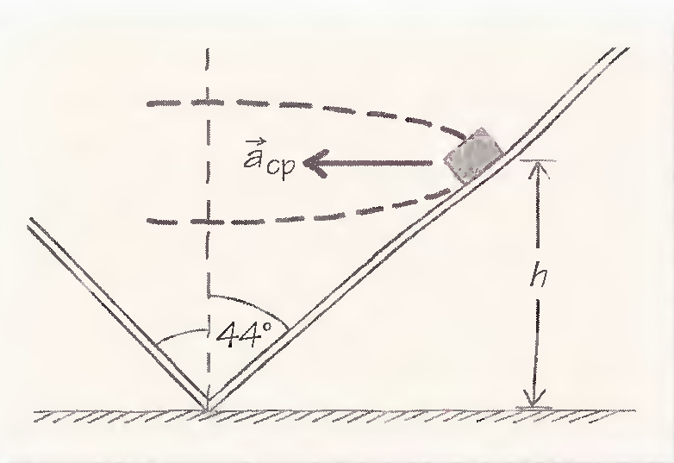

Vectors

16
Three charges move through space with no forces acting on them except the electric forces that they exert on each other. In an appropriate coordinate system, some of the forces can be broken down as follows: The force that charge 1 exerts on charge 2 is
F₂₁ = (2 N)i + (-3 N)j + (1 N)k.
The force that charge 1 exerts on charge 3 is
F₃₁ = (-3 N)i + (2 N)j + (-3 N)k.
a) What is the total force on charge 1?
b) What is the magnitude of the net force on charge 1?
{Answer: a) (i+j+2k) N; b) 2.44949 N (6^{0.5} N)}

Projectile Motion

17
An astronaut on a planet finds that she can jump a maximum horizontal distance of 15.0 m if her initial speed is 3.00 m/s. What is the gravitational acceleration on the planet?
{Answer: 0.6 m/s²}

18
A projectile is fired in such a way that its horizontal range is equal to three times its maximum height (i.e. the maximum height during this flight). What is the angle of projection?
{Answer: 53.13010° (0.927295 rad)}

19
Someone standing on a down-tilting inclined plane making an angle of 30° with the horizontal throws a ball horizontally with a velocity of 10 m/s. How far down the plane will the ball strike the plane?
{Answer: 13.6054 m}

20
A body starts its projectile motion from initial height of 10 m with initial velocity (12i+10k) km/hr. What is its range of flight when it falls on the ground? (i and k gives horizontal and vertical directions respectively, positive k directed upward).
{Answer: 5.79955 m}

Liquids

21
A swimming pool has dimensions 30 m x 10 m and a flat bottom. When the pool is ﬁlled to a depth of 2 m with fresh water, what is the force caused by the water on the bottom? On each side?
{Answer: 5.88 MN on the bottom, 294 kN on the 30 m side and 98 kN on the 10 m side}

22
The spring of the pressure gauge shown in a figure below has a force constant of 1000 N/m, and the piston has a diameter of 2 cm. As the gauge is lowered into water, what change in depth causes the piston to move in by 0.5 cm?
{Answer: 1.62403 m}

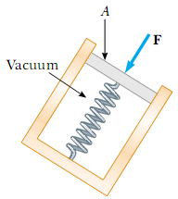

23
A large storage tank, open at the top and filled with water, develops a small hole in its side at a point 16 m below the water level. If the rate of flow from the leak is equal to 2.50 l/min (litre per minute), determine
(a) the speed at which the water leaves the hole,
(b) the diameter of the hole.
{Answer: a) 17.70875 m/s; b) 1.730834 mm }

24
A wedge of mass 10kg and opening angle Θ= 55° is floating on the surface of water in the symmetrical position. Calculate the force of the water that acts on each of the two surfaces.
{Answer: 106.118 N}

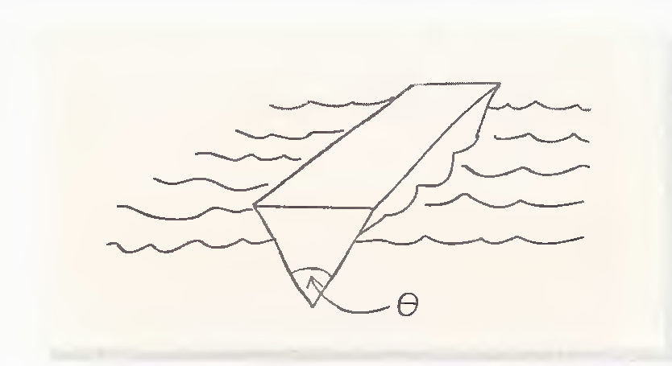

25
A waterfall of height 40 m has 200 m³ of water falling every second. How many joules of work are done by gravity every hour?
{Answer: 282.24 GJ}

Collisions

26
A machine gun in automatic mode fires 20g bullets with 300 m/s at 60 bullets/s rate.
(a) If the bullets enter a thick wooden wall, what is the average force exerted against the wall?
(b) If the bullets hit a steel wall and rebound elastically, what is the average force on the wall?
{Answer: a) 360 N; b) 720 N}

27
Two objects with masses 2.0 and 3.0 kg move toward each other, both with speeds V₀ = 5.0 m/s. They collide head on and stick together.
(a) Calculate their final velocity.
(b) Calculate the amount of kinetic energy lost during the process.
(c) Suppose the two masses approach each other at 90° before the collision (e.g., along the x- and y-axes). What will be the kinetic energy loss in this case?
{Answer: a) 1 m/s; b) 60 J; c) 30 J}

28
A 7-kg rifle is used to fire a l0-gr bullet that travels with a speed of 700 m/s.
(a) What is the speed of recoil of the rifle?
(b) How much energy does it transmit to the shoulder of the person using the rifle as it stops?
{Answer: a) 1 m/s; b) 3.5 J}

Torque

29
A uniform rod of length L lies along the x-axis. A force F_{1y} is applied to one end of it and a force -F_{2y} is applied to the other end of it. How large is the torque on the rod about its center of mass?
{Answer: L(F_{1y}+ F_{2y})/2}

30
A two-dimensional object placed in the xy-plane has several forces acting on it. Find the torques about points A and B.
{Answer: A: 17 N·m; B: -19 N·m}
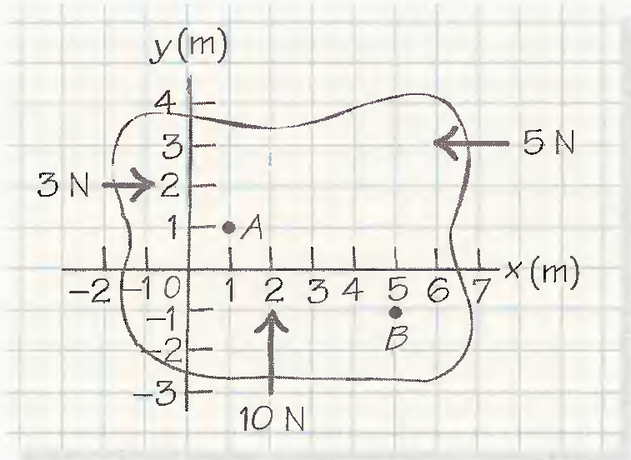

31
A seesaw pivots as shown in a picture below.
(a) What is the net torque about the pivot point?
(b) Give an example for application of the third force will balance the seesaw. Calculate the position and magnitude of the balancing force.
{Answer: a) -2.3 N·m; b) A downward force of 1 N at 2.3 m to the left of the pivot point}

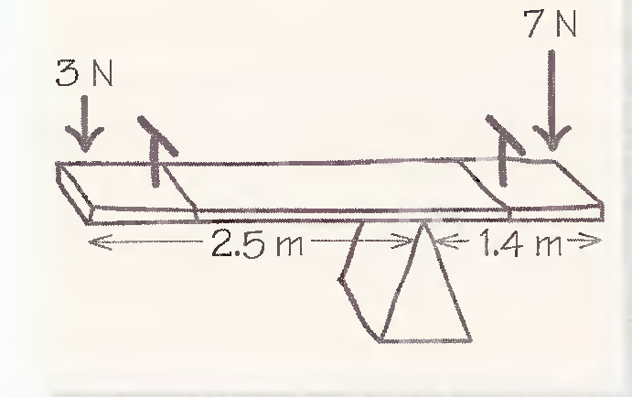

Rotational Dynamics

32
A massless rope is wrapped around a hollow cylinder of radius 12 cm whose central axis is fixed in a horizontal position. A mass of 4.0 kg hangs from the rope and, starting from rest, moves 180 cm in 2.0 s. What is the mass of the cylinder?
{Answer: 39.556 kg}

33
A body rolls without slipping and have uniform density, mass M. and radius R and the speed of the center of mass is V. Find the ratio of the rotational kinetic energy to the total kinetic energy for:
(a) solid cylinder,
(b) hollow cylinder,
(c) solid sphere,
(d) hollow sphere.
{Answer: a) 1/3; b) ½; c) 2/7; d) 2/5}

34
A centrifuge whose maximum rotation rate is 10000 rev / min can be brought to rest in 400 s.
(a) What is the average angular acceleration of the centrifuge?
(b) What is the distance that a point on the rim travels during the deceleration time assuming that the radius of the centrifuge is 8 cm and that the acceleration is uniform?
{Answer: a) -2.61799 rad/s²; b) 16.75516082 km}

35
A string is wrapped around a cylindrical spool of radius 1 cm, The axis of the spool is fixed. A length of string of 0.8 m is pulled off in 1.5 s at a constant tension of 20 N. What is the rotational inertia of the spool?
{Answer: 2.8125 g·m²}

36
A cylindrical shell starting from rest rolls down an inclined plane that makes an angle of 20° with the horizontal. How far will the shell travel in 4 s? How far would a solid cylinder travel in the same time?
{Answer: 13.407 m; 17.876 m}

